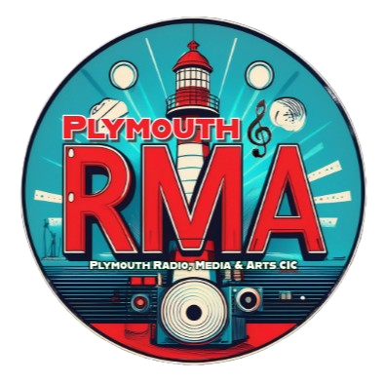
Plymouth Radio, Media & Arts CIC Safeguarding Policy
active for all branches of PlymouthRMA and its Trading names.

Content | Page Number
Description on terminology | 1
Appointed supervisor | 1
GDPR | 2
Photographic Content | 2
Social Media & Personal Contact with a client | 2
Social Media & Personal Contact with service users | 2

Description of terminology:

Service User - A person who is involved with PlymouthRMA under supervision of a member of staff.. Service users do not hold any responsibilities or permissions within the company.

Clients - A person who accesses the company services without any involvement in PlymouthRMA long term. (Radio listener, Shop Customer etc).

Member of staff - A volunteer or paid member of staff involved with PlymouthRMA who operates their responsibilities or permissions unsupervised by company management.
Member of management - A member of staff with extra responsibilities and authorities to operate and facilitate on behalf of the board of directors.

Directors - These are the people who are legally responsible for PlymouthRMA CIC and oversee all activity that happens within the company.

Appointed Supervisor (Buddy)
An appointed supervisor is someone who has the responsibility of monitoring a service user whilst they are involved with PlymouthRMA.
This individual would be a responsible member of staff with relevant up to date paperwork.
This person would be responsible for ensuring the service user is safe at all times whilst in PlymouthRMA’s care.

GDPR
PlymouthRMA holds a GDPR statement stating how we process and personal information which is downloadable from our website www.PlymouthRMA.com
But in a nutshell, we do not share information and information is kept in a secure location.

Photographic Content
Photographic content of all members of staff, service users & clients are only distributed with permission. All permission is collected on a signed agreement. The photographic content with permission can be posted on social media, shared with third party companies & displayed within our venues.

Social Media & Personal Contact with clients
Members of staff do not have permission to have contact with clients outside of operating times using their personal forms of contact (such as facebook, personal phone number ), without mutual agreement from the client and company management. For reasons such as working from home, or working at an off-site location.
Clients that wish to contact members of staff must do so by using the authorised company social media, telephone or email addresses or by coming to the company premises during operating times.

Social Media & Personal Contact with service users
Members of staff do not have permission to have contact with service users outside of operating times, service users that wish to contact members of staff must contact members of staff using the authorised company social media, telephone or email addresses or by coming to the company premises during operating times.
Members of staff that have previous acquaintance with a service user before joining the company must declare their relationship with management, they will be permitted to continue this acquaintanceship.
Members of staff are not permitted to have direct contact with service users through their personal social media or point of contact such as Facebook & Personal Telephone Number and other forms of contact not authorised by the company.
Only an appointed supervisor has authority to have contact with services users using authorised forms of contact. The appointed supervisor should follow up with any contact made by the service user, unless permission granted by a member of management.

Signed: _____________
Role:_______________
Date:__/__/____

